International Conference & Exhibition: 17th World Renewable Energy Technology Congress along with
10th World Water Summit & Expo, 7th World Hydrogen Energy Summit & Expo
and 6th World Waste to Wealth Summit & Expo-2026

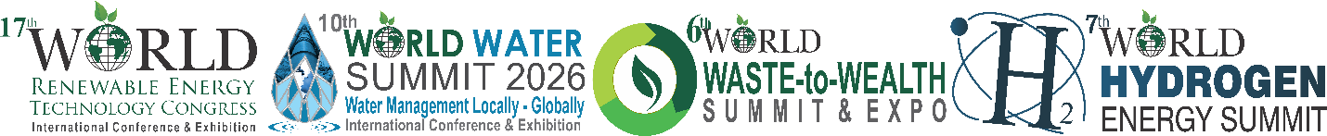
1st – 2nd July 2026 | NDMC Convention Centre, New Delhi
Registration Form
[Prior Registration is mandatory, due to high security arrangements at NDMC-Convention Centre, Parliament Street]
I / We would like to participate / nominate the following for the Conference:

Sl. No | Name | Designation | Mobile | Email
1
2
3
4
5
Organization / Institute / University:

Address:

Ticket Type Price Quantity

Delegate Pass INR 22000 | US$ 500
All Days Access to the Premium Conference Plus 18% GST
Author Pass INR 20000 | US$ 400
All Days Access to the Premium Conference Plus 18% GST
Student Delegate Pass INR 8000 | US$ 200
All Days Access to the Premium Conference Plus 18% GST

PAYMENT METHOD
For Electronic Transfer | For UPI Payment
Account Name : Energy And Environment Foundation  Account Number : 629705015384  Branch : ICICI Bank Ltd.  C-24-25, Acharya Niketan, Mayur Vihar-I  Delhi-110091, India  IFSC Code : ICIC0006297  Swift Code : ICICINBBCTS | 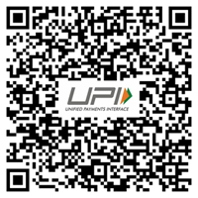

NOTE: Original Aadhar Card/ PAN Card to show Entry Gate of NDMC-Convention Centre, for necessary verification by the Security.
Please complete the form and mail/fax/email
Dr. Anil K. Garg, CEO, Energy And Environment Foundation Ph.: 91-11-22758149, 22757049 | dranilgarg2024@gmail.com

